Data base creation (11th Apr)

Code

Attempt 1

CREATE TABLE TRIANGLES

(TRIANGLE INT,

SIDE_A INT,

SIDE_B INT,

SIDE_C INT);

INSERT INTO TRIANGLES VALUES

(1,20,20,23)

(2,20,20,20)

(3,20,21,22)

(4,13,14,30);

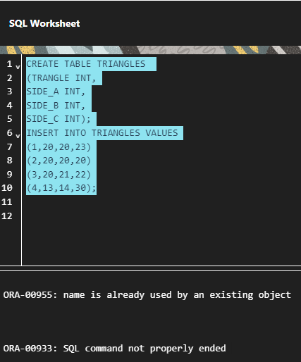

Attempt 2.

CREATE TABLE TRIANGLES

(TRIANGLE INT,

SIDE_A INT,

SIDE_B INT,

SIDE_C INT);

INSERT INTO TRIANGLES VALUES

(1,20,20,23)

(2,20,20,20)

(3,20,21,22)

(4,13,14,30);

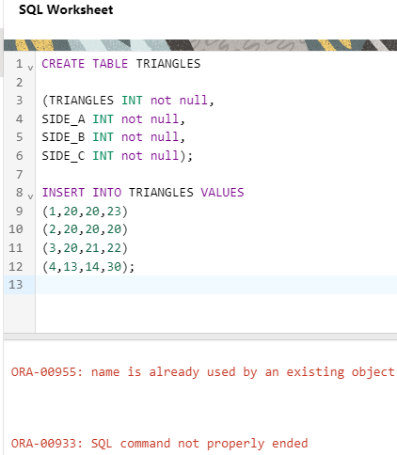

Attempt 3

create table triangle

(Triangle int,

Side_A int,

Side_B int,

Side_c int

)

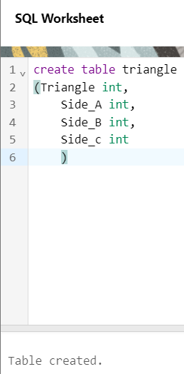

INSERT INTO TRIANGLE (TRIANGLE, SIDE_A, SIDE_B, SIDE_C)

VALUES

(1,20,20,23);

(2,20,20,20);

(3,20,21,22);

(4,13,14,30);

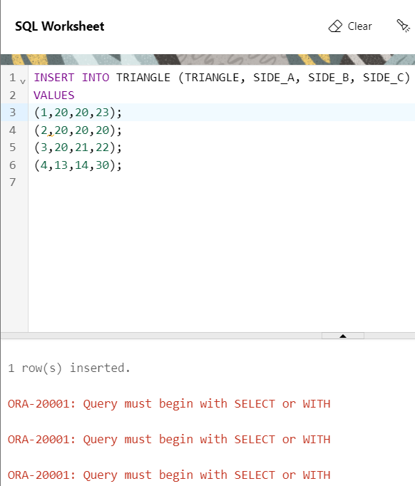

Attempt 4

create table triangles

(Triangle int,

Side_A int,

Side_B int,

Side_c int);

insert into triangles values(1,20,20,23);

insert into triangles values(2,20,20,20);

insert into triangles values(3,20,21,22);

insert into triangles values(4,13,14,30);

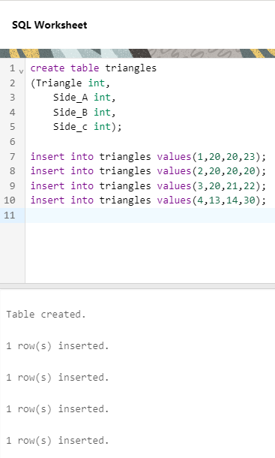

Q.

i) Write a query to obtain the sum of side_A of all triangles.

**SELECT SUM(SIDE_A) AS TOTAL_SIDE_A FROM TRIANGLES;**

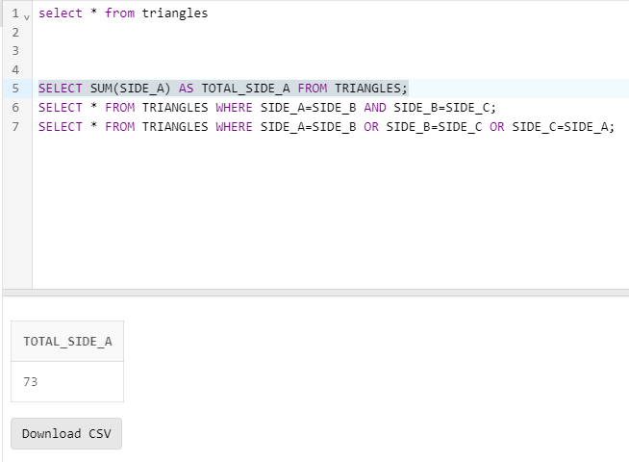

ii) Write a query to obtain an equilateral triangle from the table.

(Note:- Equilateral triangle is a triangle in which all three sides

have the same length)

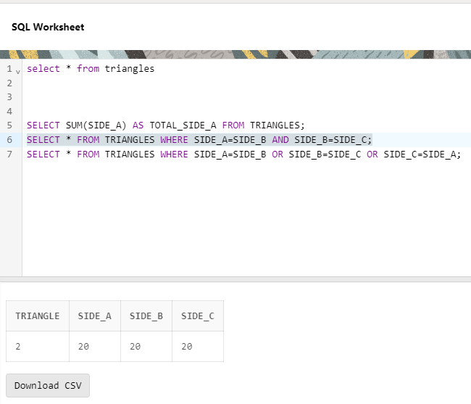

iii) Write a query to obtain an isosceles triangle from the table

(Note:- An isosceles triangle is a triangle that has two sides of

equal length)

SELECT * FROM TRIANGLES WHERE SIDE_A=SIDE_B OR SIDE_B=SIDE_C OR SIDE_C=SIDE_A;

Contains equilateral also

SELECT * FROM TRIANGLES WHERE SIDE_A=SIDE_B<>SIDE_C OR SIDE_B=SIDE_C<>SIDE_A OR SIDE_C=SIDE_A<>SIDE_B;

Why not working

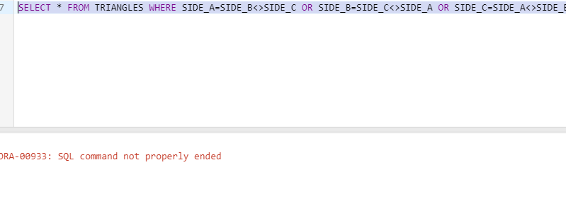

Attempt 2

SELECT *

FROM TRIANGLES

WHERE SIDE_A = SIDE_B AND SIDE_A <> SIDE_C

OR SIDE_B = SIDE_C AND SIDE_B <> SIDE_A

OR SIDE_C = SIDE_A AND SIDE_C <> SIDE_B;

